[USE TIMES NEW ROMAN – LEFT JUSTIFY ALL TEXT]

President’s Research
“Presidents Make Good Leaders”
Lesson Plan

Author: Linda Tetreau, Massabesic Middle School, Social Studies/ US History
Suggested Grade Level:[8th grade
Subject Area: Social Studies, Government,& Language Arts

Learning Results/Common Core: We use the Learning Targets developed by the Maine Cohort
I have attached PDF files for the Learning targets covered.
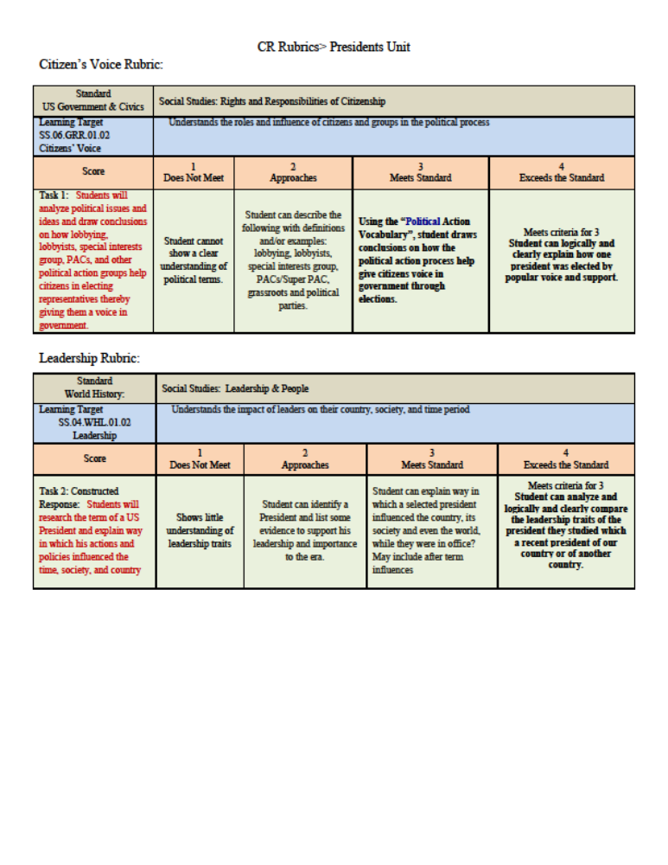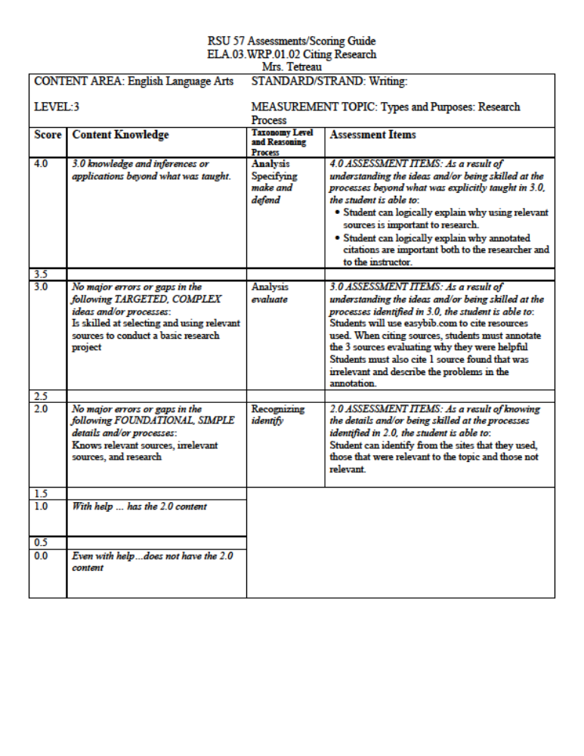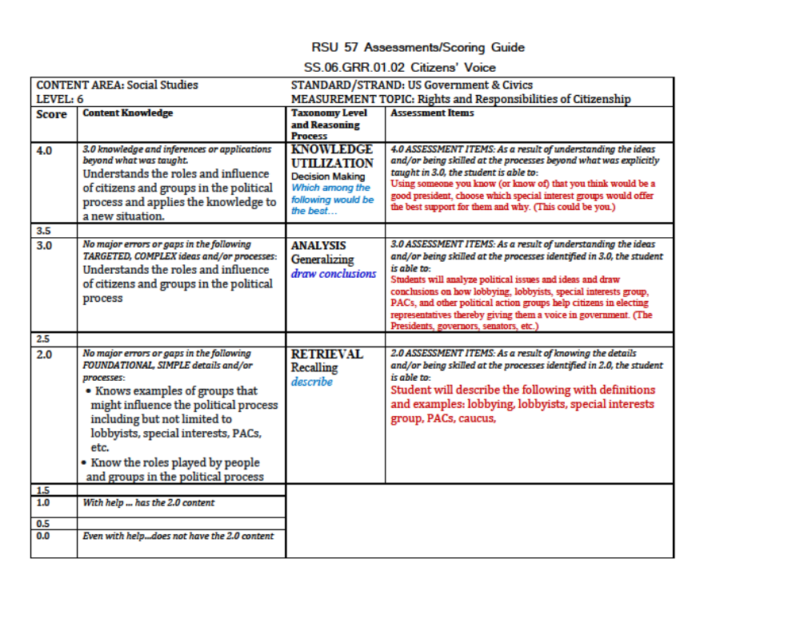
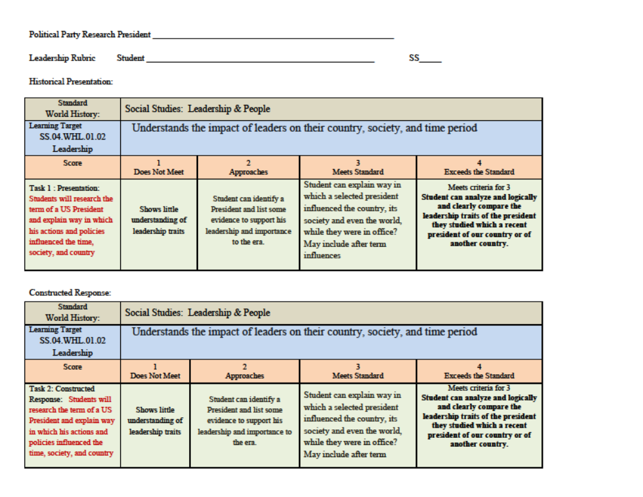
Time Required:
[2 to 3 weeks]

Learning Objectives:
[To show students how elections allow them to have a voice in running our country]

Materials and Resources Required:
[Any history texts and any encyclopedia]
Research Sites/Political Parties
http://www.u-s-history.com/pages/eras.html
Good information. If it shows up in a search, use it. It is hard to search the site itself. It has no internal search. There are lots of ads.
http://presidentelect.org/index.html
This site gives brief overviews of election information, you just pick the election year.
http://www.historycentral.com/index.html
Good information. This site does have many political ads. You can search the site but be careful. It also gives you links to other sites. Know when you leave the site!
http://www.history1700s.com/index.html
All things 1700’s. You can’t search within the site but they do have a table of contents. If this site comes up in your search, use it.
http://www.presidency.ucsb.edu/showelection.php?year=1796
This is a good site for election data. It also gives information on presidential speeches, proclamations, etc. Not all election years are covered for all topics. Choose the “ELECTION” tab to find your election year.
http://loc.gov
This is the official Library of Congress Site. It is search able but takes time to sort through and find just what you need. Great place for pictures, documents, and recordings.
http://si.edu
This is the official site of the Smithsonian Museum. This is a searchable site but will take time to sort through.
http://whitehouse.gov
The official White House site.

Preparation Required/Preliminary Discussion:
[I use the introduction material attached and a PowerPoint for an introduction.]

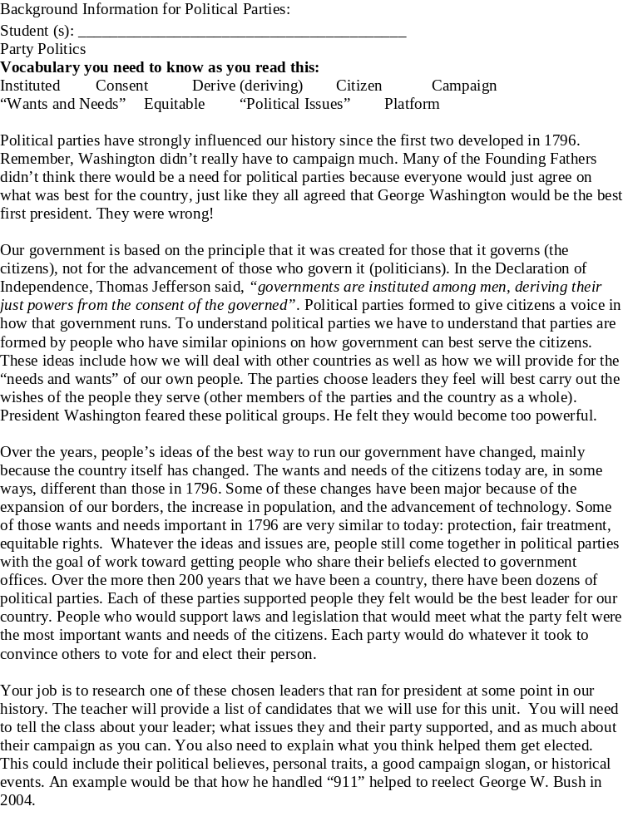Lesson Outline:
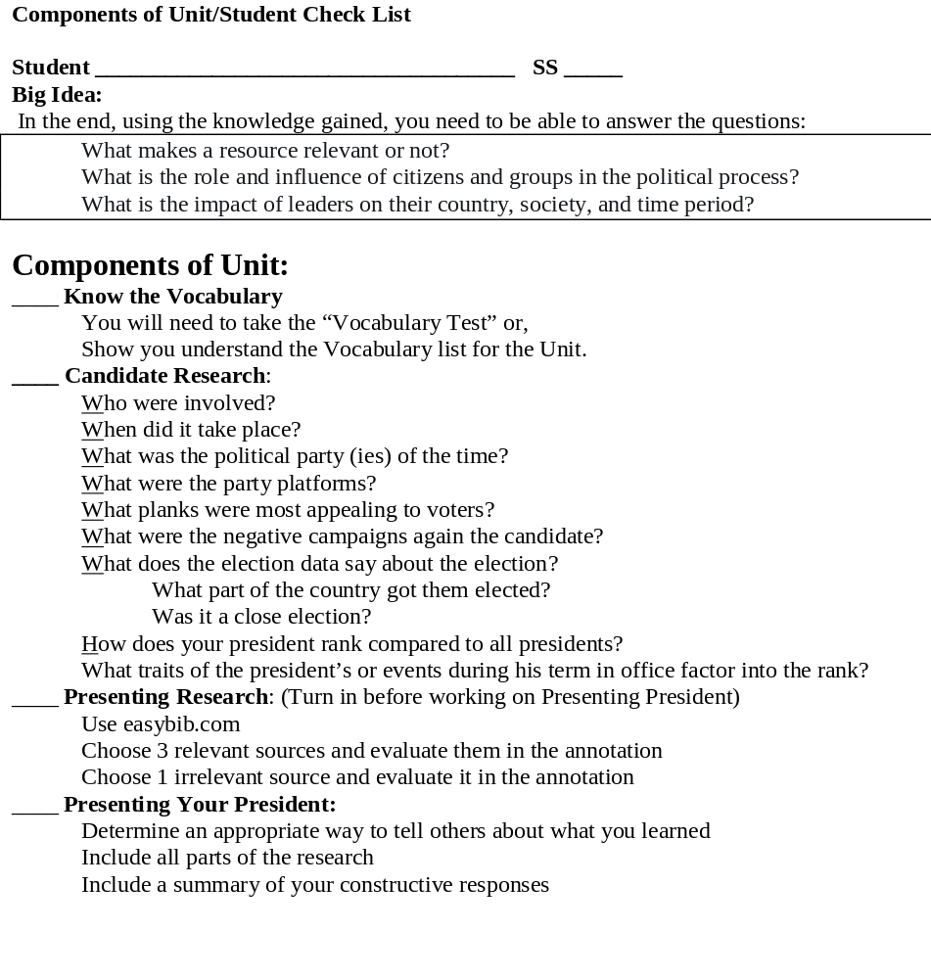
Assessment Summary:

After the Lesson Evaluation:
I did this lesson with my students just before the 2012 elections. The kids were assigned their presidents randomly. For the rest of the year I always have one or two students who can add details about the president in office during that era. For another time I might pull out those presidents who were not in office long enough to make an impact. The students found those particularly hard to do.


